Learning Insights from the Causal Inference Analysis of Victorian Sentencing – RQ3
This work is based on Old-bailey guilty cases
Main Causal Findings:
Male-on-female cases are causally more likely to receive hard labour or a worse sentence, but the dramatic capital-sentencing gap is almost entirely due to the types of crimes they commit, not the gender configuration itself.
Summary:
The raw sentencing data for male-on-female cases produced three findings that together reshape how we read Victorian sentencing practice. First, male-on-female cases were under-represented at both middle tiers of the sentencing distribution: 3.1 percentage points fewer ended in non-custodial sentences and 3.1 percentage points fewer ended in hard labour, compared with the rest of the corpus. Second, they were over-represented at both extremes — 3.5 percentage points more ended in ordinary custodial prison, and 2.7 percentage points more ended in capital or transportation sentencing.
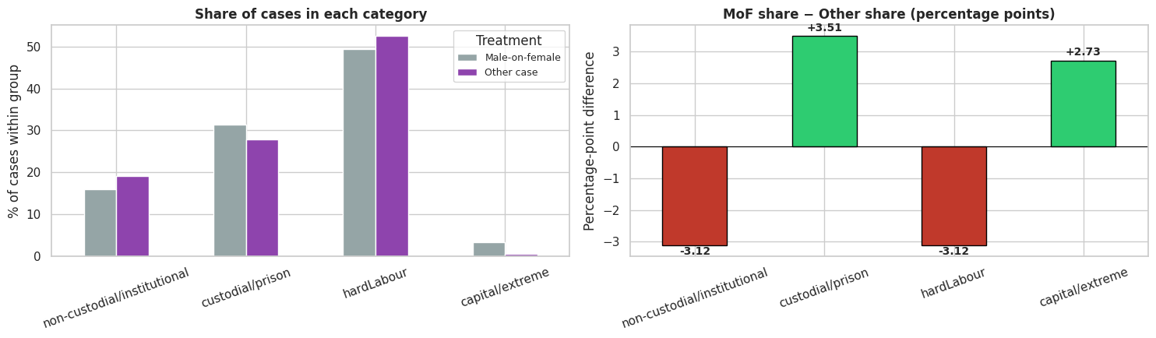
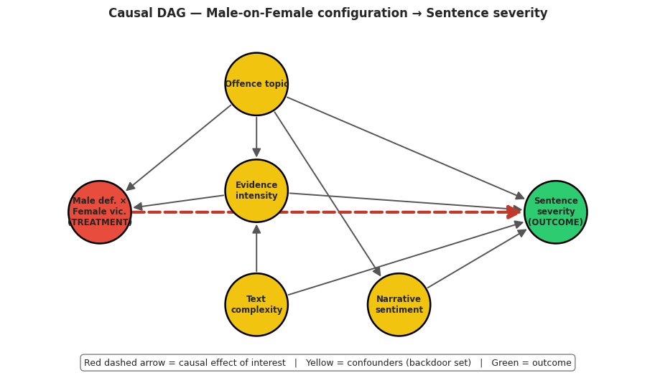
Third, the capital-rate gap was the most striking single statistic: 3.19% of male-on-female cases received capital sentencing, compared with 0.46% of other cases — a sevenfold relative increase. This U-shaped distribution contradicts a simple "lenient" or "harsh" framing of how Victorian courts handled offences by men against women; the pattern is neither uniformly protective of female victims nor uniformly lenient toward male defendants. What the raw data suggests instead is that male-on-female cases occupied a different sentencing regime from the rest of the corpus — one that funnelled cases away from the ordinary middle tiers and concentrated them at the two ends of the severity spectrum.
LDA Topic Modelling and DoWhy Causal Inference
The LDA topic analysis demonstrated that male-on-female cases clustered heavily in a small number of offence categories with distinct legal character. Topic 2 ("child, wife, house, examined") was 49% male-on-female and represents domestic and family violence; Topic 5 ("street, police, house") was 33% male-on-female and represents street-level assaults; while Topic 9 ("coin, counterfeit, bad") — coining and counterfeit-uttering offences — was only 3% male-on-female. This clustering proved decisive for the causal analysis because it meant the raw contrasts were conflating gender-party configuration with offence type. After applying five independent causal estimators (regression, PSM, IPW, AIPW, and DoWhy) with offence topic and evidentiary features held constant, three findings emerged. On the corrected ordinal severity scale, male-on-female cases received sentences +0.07 severity-rank units harsher than comparable other cases — small but statistically robust across all methods.
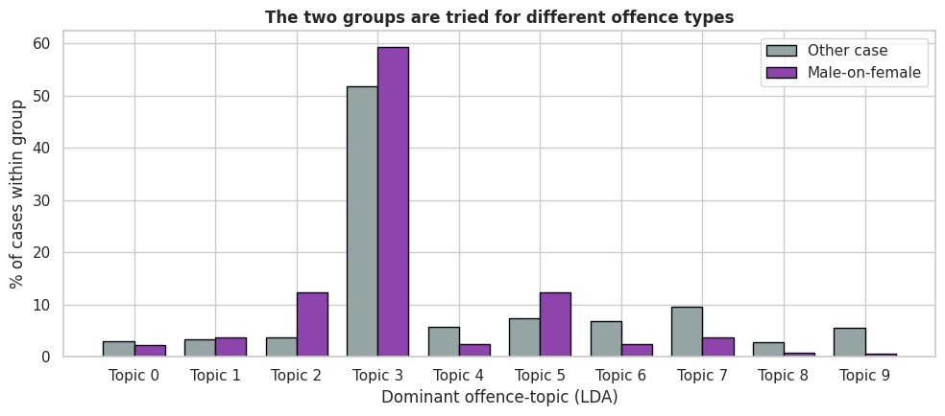
On the binary severe-band outcome (hard labour or worse), the adjusted causal effect grew to +4.4 percentage points, meaning that for two otherwise-comparable cases, the male-on-female configuration causally raised the probability of a severe sentence by roughly 4 in every 100 cases; notably, the naive gap here was essentially zero, so confounder adjustment revealed this causal effect rather than shrinking it. On the capital outcome specifically, the dramatic 7× raw rate collapsed to a small residual effect of about +0.4 percentage points after adjustment — meaning most, though not all, of the raw capital gap was explained by offence-type differences. All three findings survived DoWhy's refutation battery (placebo treatment, random common cause, data-subset refuter), giving us reasonable confidence that the pattern is not a statistical artefact.
Close Reading As Grounding Statistics in Legal Content
Close reading transformed each statistical finding into a concrete historical pattern with legal content. The 7× capital-rate gap turned out to be, almost literally, the over-representation of wilful-murder-of-women cases among Victorian capital sentencing: of 75 total capital sentences in the corpus, 50 (67%) were male-on-female, and reading the opening words of every single one showed that nearly all were wilful-murder indictments naming a female victim as wife, partner, or relative. This is not an abstract statistical pattern — it is the specific Victorian phenomenon of male-partner lethal violence against women being the modal path to capital sentencing. The matched-pair readings made the causal comparison visceral: Robert Earl's indictment for the wilful murder of Margaret Pamphilon (capital sentence) was matched by the algorithm at near-zero propensity distance against Herbert Madden's indictment for the wilful murder of his son (non-custodial), showing that even within the narrow band of homicide indictments the configuration of parties mattered for outcomes. 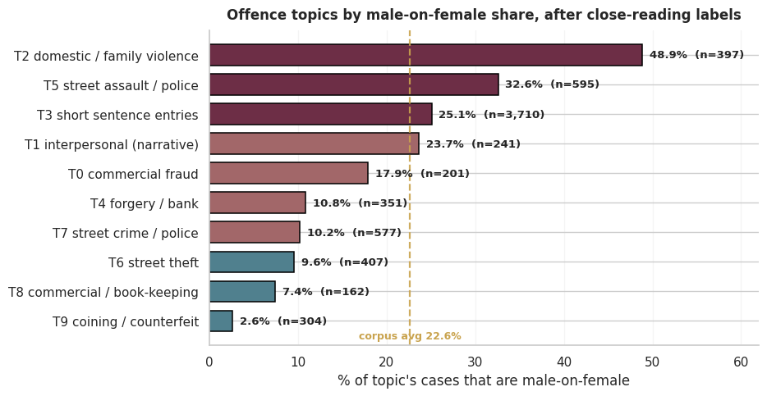
Close reading also exposed an encoding limitation that inflates our confidence in the findings: rape and bigamy convictions sentenced to penal servitude — which almost by definition are male-on-female cases — were coded in this dataset as "custodial/prison" (severity rank 1) rather than hard labour (rank 2), placing them below our severe-band threshold. A historically defensible re-coding would move these cases up and almost certainly increase the estimated severe-band effect beyond 4.4 percentage points. Taken together, the three phases of analysis point to a consistent historical reading: male-on-female cases in Victorian criminal courts did not receive uniformly harsher or lighter sentences, but rather operated under a distinct sentencing calculus in which domestic and partner violence drove concentration at the capital end, while the middle tiers showed a systematic shift toward slightly harsher outcomes — concentrated in specific offence categories where statute and discretion converged.

